/chapter

Ernö Rubik is the inventor behind the world famous Rubik's cube. He was born in Budapest, Hungary in 1944. In college he studied sculpture. After his graduation he started studying architecture. Once he graduated in architecture he stayed at the college to teach interior design.
Rubik got the idea for the cube when he wanted to make a 3D design with blocks that could move individually but many at the same time. Rubik initially tried to make a cube that was held together with rubber bands but failed. Then he got the idea that the cubes had to hold each other in place. Rubik got the inspiration for the cube from the Magic puzzle \ref{Recreational mathematics}. At first the cube was named the Magic Cube. The company Ideal Toy bought exclusive rights for the Magic Cube, but changed the name of the cube to Rubik’s Cube within a year in order to get trademark protection.
%Rubik said some of the most important features behind the cube were that the parts of the cube stay %together, which many other puzzle don’t. He also pointed out that you can move several pieces at once. %Also that it is three dimensional.
%Omskrevet af Mikael:
Rubik mentioned that the most important feature of the cube was that the parts of the cube was able to stay together as opposed to many other puzzles. Rubik also expressed his fondness for the cube's ability to move several pieces at once and the fact that the cube is three dimensional.
In January 1975 he applied for patent for his invention in Hungary. Two years later in 1977 he got the patent on the Rubik’s cube.
At that time there were also two others applying for patent for products similar to the Rubik’s Cube. One of them was an American named Doctor Larry D. Nichols, and his cube was a 2x2x2 cube and it was held together with magnets. The other one who applied for patent was a Japanese man named Terutoshi Ishige. He applied for patent a year after Rubik. Terutoshi Ishige's cube was almost identically to the Rubik’s cube.
The Nichols Cube Puzzle:
Dr. Larry D. Nichols has studied chemistry on DePauw University in Greencastle, Indiana, before moving to Massachusetts to attend Harvard Graduate School.
He is a lifelong puzzle enthusiast and inventor who began developing a twist cube puzzle with six colored faces in 1957. It was made of eight smaller cubes assembled to a 2x2x2 cube. The eight cubes were held together by magnets. 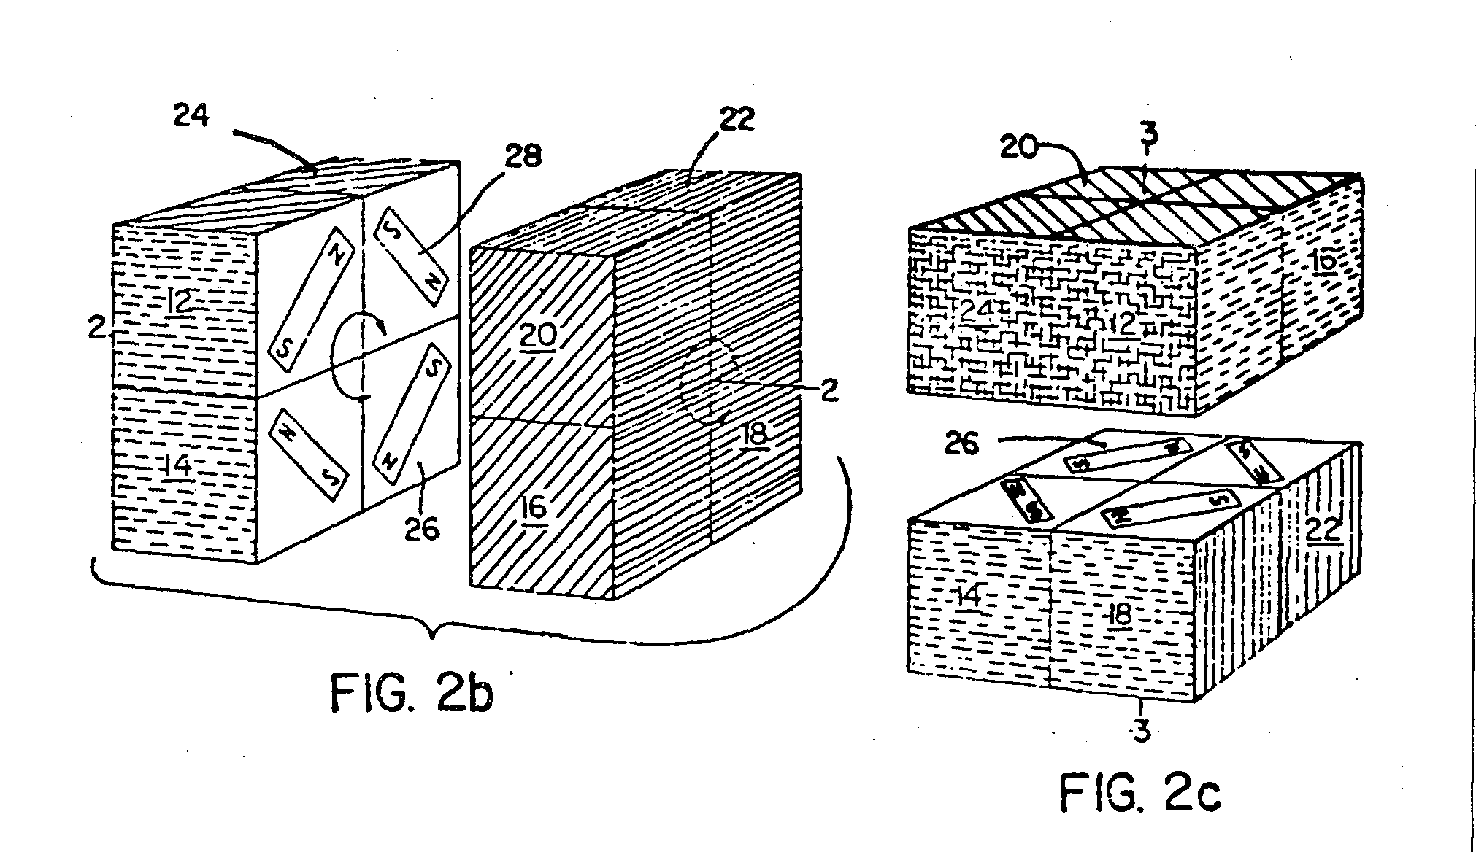

On April 11 1972 he was granted U.S. Patent 3,655,201 on behalf of Moleculon Research Corp. U.S. Patent 3,655,201 covered Nichols Cube and the possibility for making larger versions later. This was two years before Ernő Rubik took out the patent for his Rubik’s Cube.

In 1982 Moleculon Research corp. Sued Ideal Toy Company that had the U.S. Patent 4,378,116 for Rubik’s Cube because they believed that Ideal Toy Company violated their patent, but the U.S. District Court ruled in Ernö's favor. Again in 1986 the Court of Appeals ruled that the Rubik’s Pocket Cubes 2x2x2 was guilty of infringement but not the 3x3x3 Rubik’s Cube.
%Rettet af Mikael 17/2 10:56

